**Disability Compensation Application Product Guide**

Table of Contents

Document Change Log 3

Disability Claim Application Overview 3

User Access 3

Who can access these tools? 3

How can users access these tools? 3

Navigation 4

Claims Wizard 5

ITF 10

Application Functionality 12

Part 1: Veteran Details: 12

Name, Date of birth, Gender 12

Contact Information: 13

Homelessness 14

High Priority Claims 16

Different Name 17

Military service history 18

Separation Pay 19

Retirement Pay and Training Pay 21

Training Pay 21

Part 2: Disabilities 22

Rated Disabilities 22

New Disabilities 22

Ancillary Wizard 24

Part 3: Supporting Evidence 26

VA Medical Records 27

Private Medical Records 28

Exam Info 30

Part 4: Additional Information 31

Payment Info 31

VA Employee 32

Retirement Pay Waiver 33

Training Pay Waiver 34

Part 5: Review Application 35

Success Confirmation 36

Check back later Confirmation message 37

Error confirmation 38

Major Issues and Error Messages 39

Can’t access application because of account 39

Intent to File (ITF) Error Messages 41

Save in Progress Messages 42

# Document Change Log

|  |  |  |  |
| --- | --- | --- | --- |
| **Version** | **Date** | **Description of Change** | **Locations of Changes** |
| 1.0 | Unknown | Initial Version |  |
| 2.0 | 7/13/23 | Start change log and add flow changes for Initial 526ez paper sync [( #56844](https://app.zenhub.com/workspaces/disability-experience-63dbdb0a401c4400119d3a44/issues/gh/department-of-veterans-affairs/va.gov-team/56844)) | Removed “Fully Developed Claim” page Moved Contact Info, Homeless, Terminally Ill sections to Part 1 Veteran Details |
| 2.1 | 7/21/23 | Updated Screenshot of VA Medical Records page to make treatment center name, disability names, country fields optional instead of required ([#60578](https://github.com/department-of-veterans-affairs/va.gov-team/issues/60578)) | VA Medical Records page |
|  |  |  |  |

# Disability Claim Application Overview

The disability claim application is the online tool (equivalent to VA Form 21-526EZ) a veteran can complete to file a disability claim.

## User Access

### Who can access these tools?

Veterans who are signed in with the highest level of identity verification on VA.gov (LOA3), and are found in the Master Veteran Index (MVI).

### How can users access these tools?

Users can sign in using their DS Logon Premium, MHV Premium, or ID.me accounts. They need to be registered as LOA3 users and found in MVI.

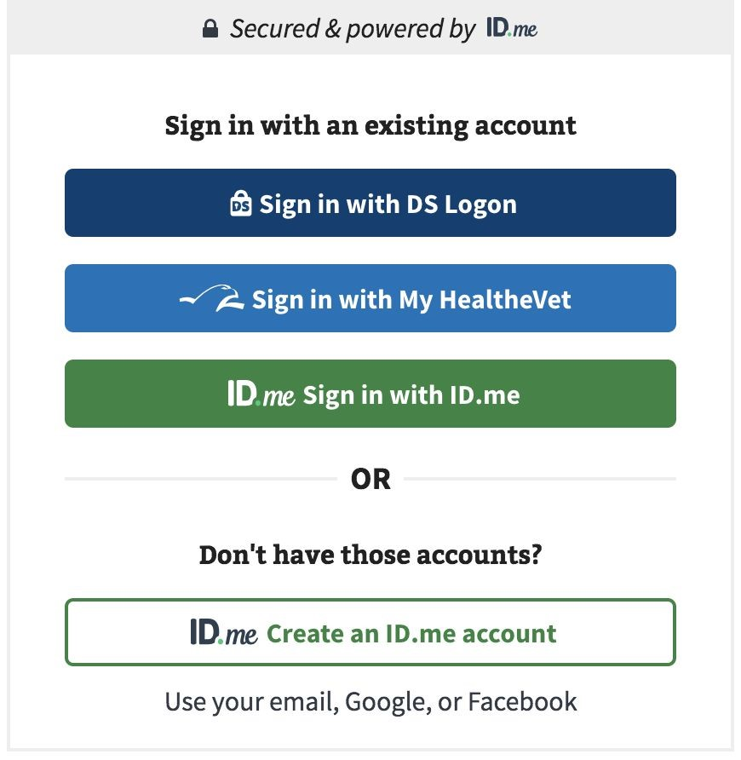

## Navigation

**Direct url:**​ https://VA.gov/disability-benefits/apply/form-526-all-claims/

or

The link for the disability claims application can be found on the ​**VA.gov**​ homepage.

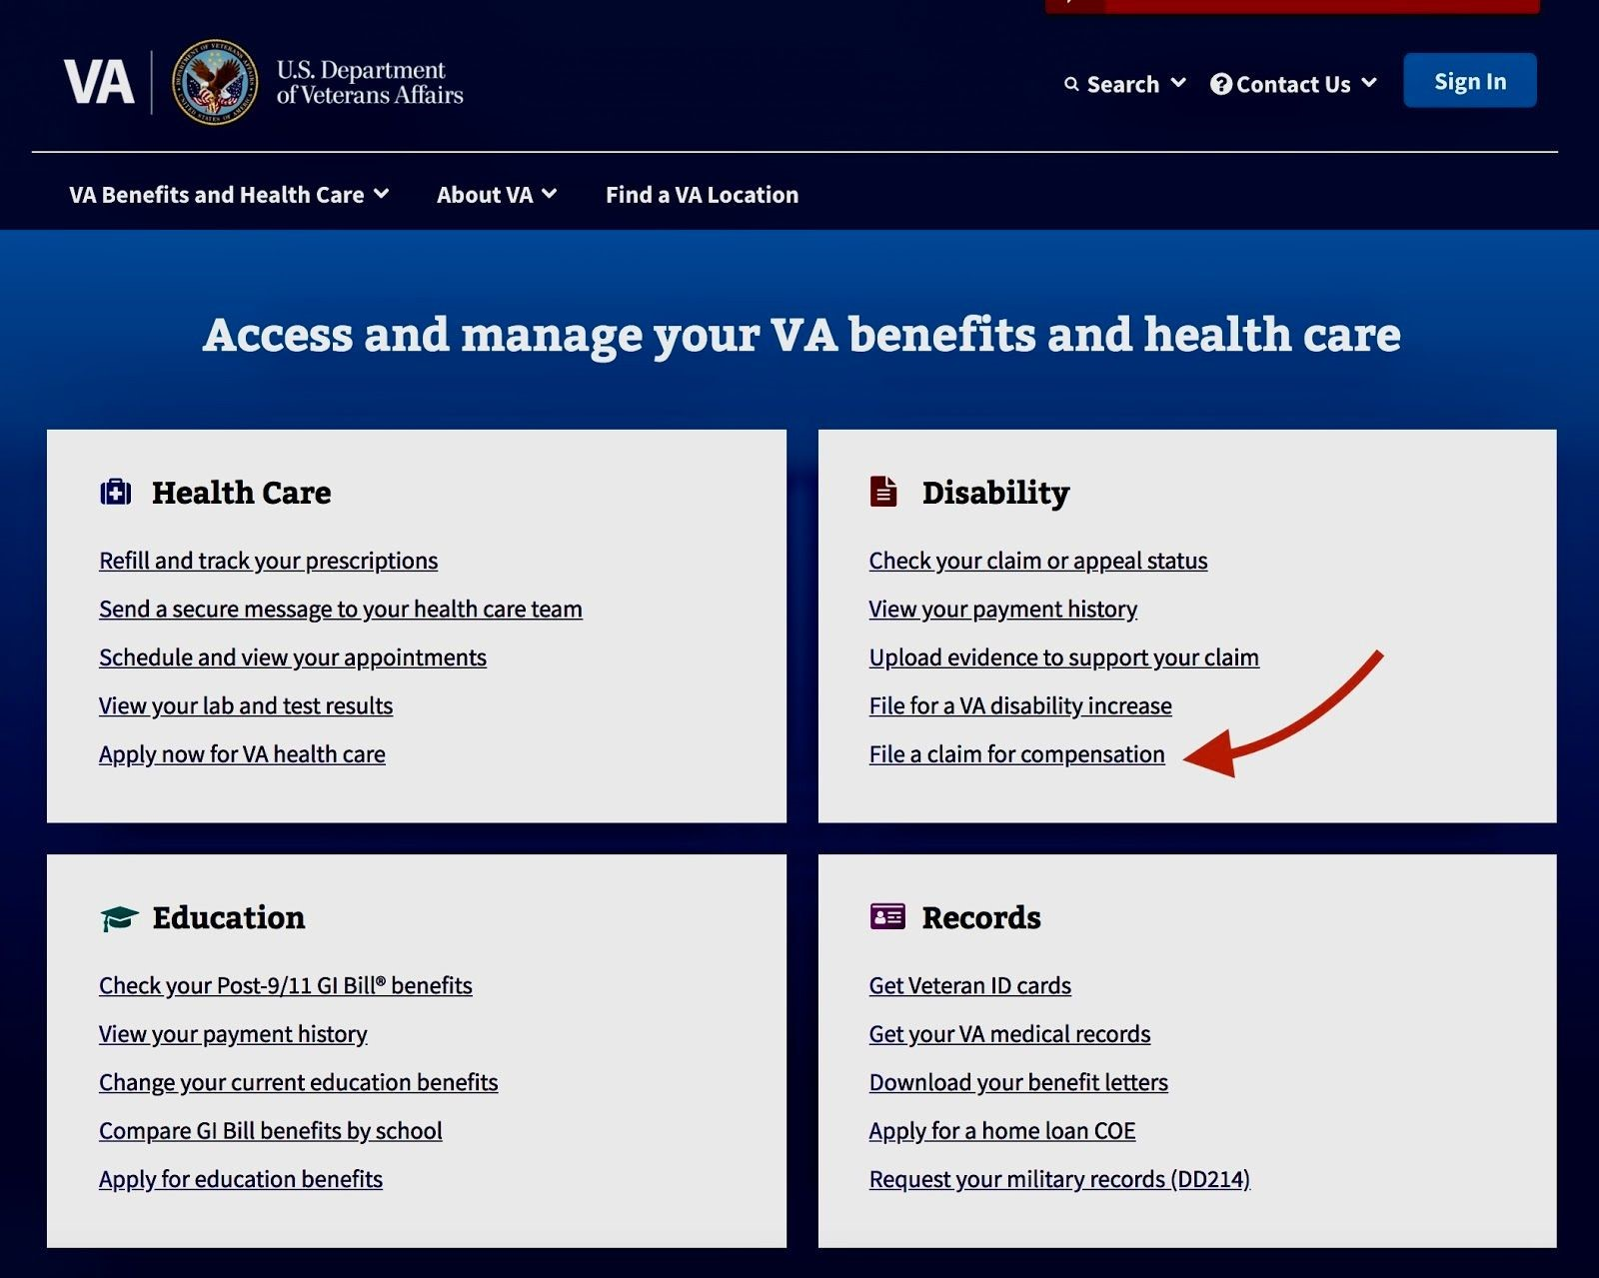

# Claims Wizard

https://www.va.gov/disability/how-to-file-claim/

A Veteran must meet certain criteria to file a claim on VA.gov The claims wizard tool asks the necessary questions to determine if the user can file a claim on VA.gov or if they need to do it on eBenefits. Below are the required criteria

* Veterans who have separated from their military or uniformed service AND
* have already filed a disability claim with the VA AND
* are filing a claim for a new or secondary disability, or for a condition that has gotten worse can use the disability claim tool.

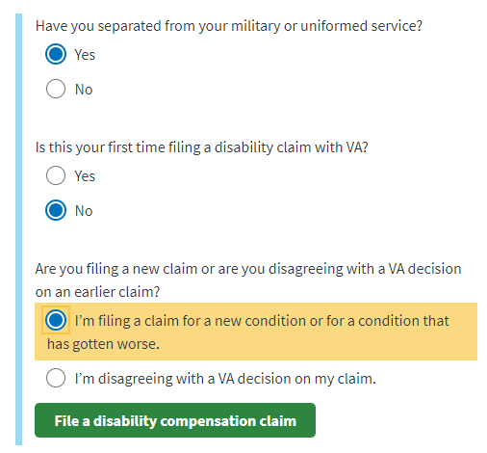

Veterans who have never filed a disability claim and Servicemembers who are less than 90 days from separation can file a claim on eBenefits.

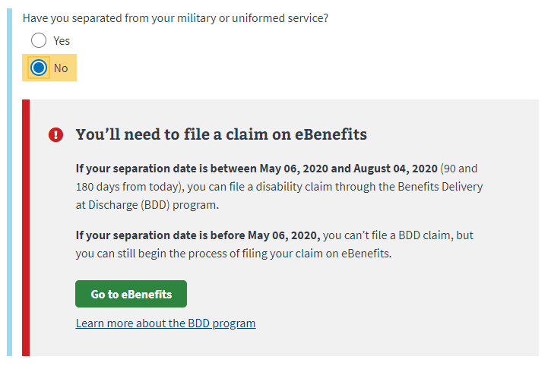

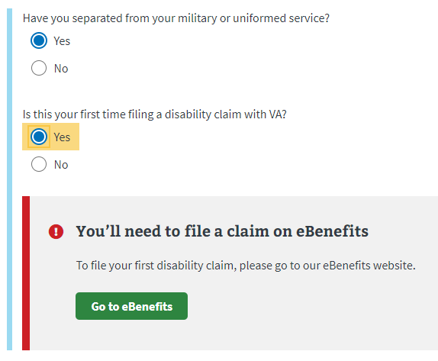

Veterans who want to disagree with a VA decision on a claim that is less than a year old will need to request a decision review:

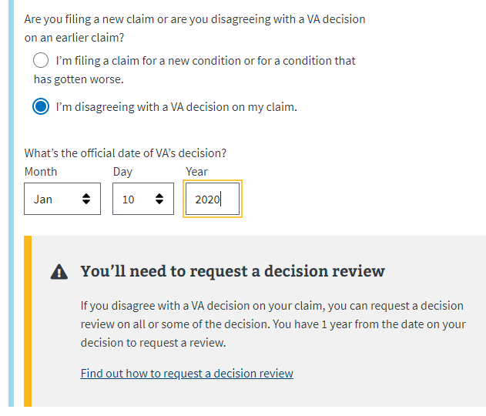

If the claim decision was made over a year ago, they will need to file a supplemental claim (VA Form 20-0995).

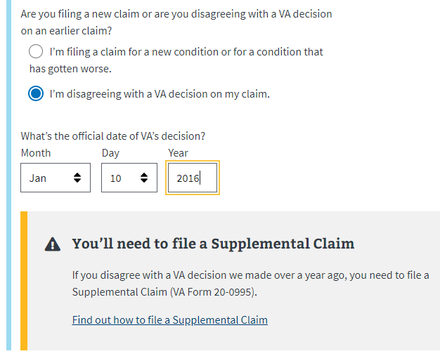

After the veteran has passed through the Claims Wizard they will be shown the below screen:

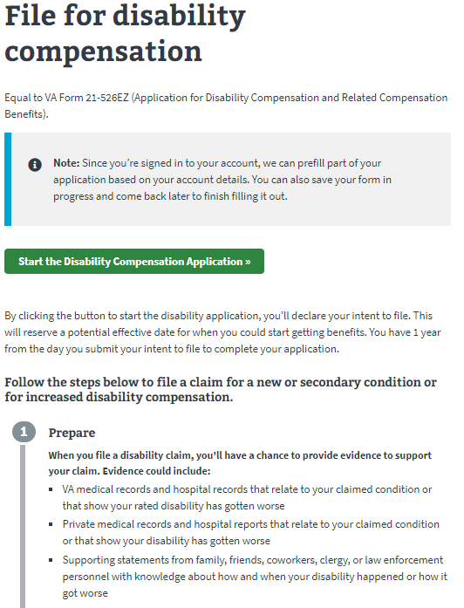

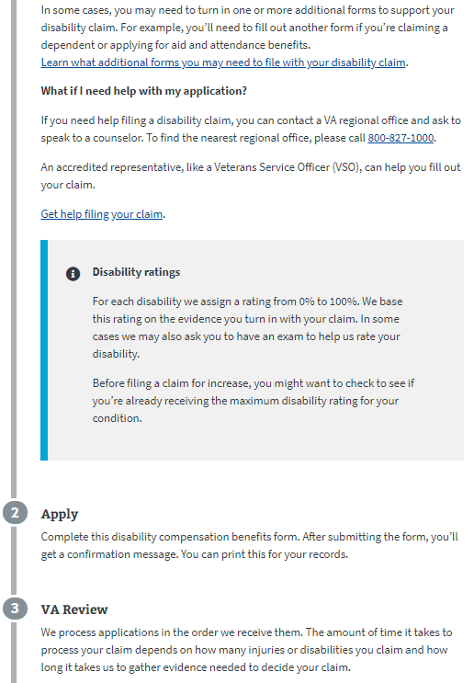

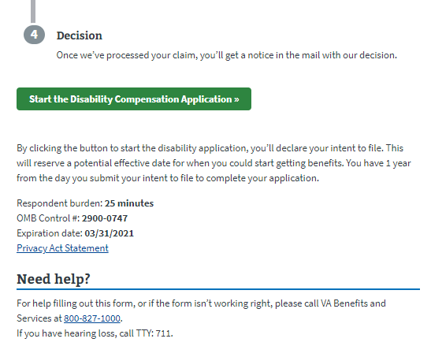

# ITF

After the veteran selects the “Start the Disability Compensation Application” button, they will be shown a message about their Intent to File. An Intent to File request lets VA know that a veteran is planning to file a claim. An Intent to File reserves a potential effective date for when a veteran could start getting benefits while they prepare their disability claim and gather supporting documents.

Depending on the records of the VA, the veteran might see different information about their ITF.

**Veteran does not have an ITF on file:** If the veteran does not have an ITF on file, they will create one by clicking the “Start the disability compensation application” button.

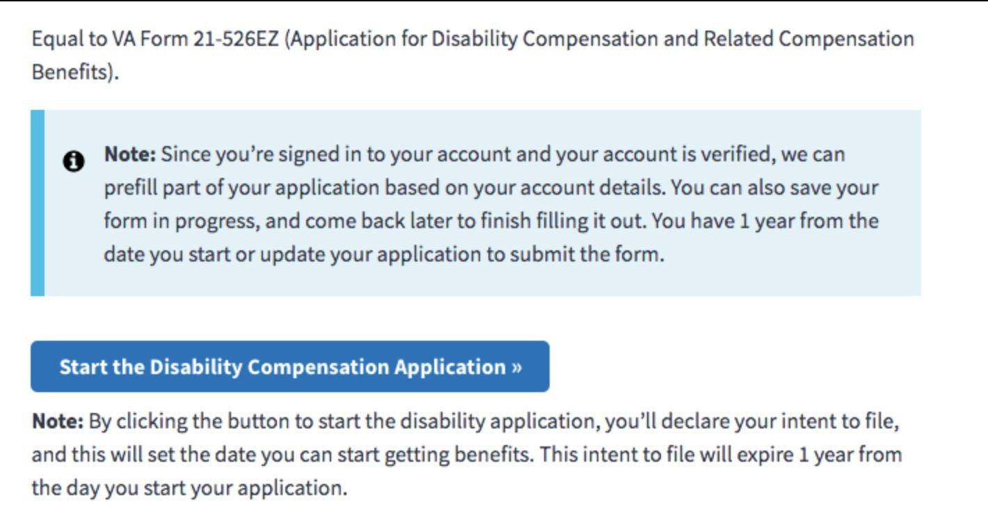

|  |  |
| --- | --- |
| ITF (description) - selecting the blue ‘Start’ button (below) will trigger the creation of an ITF (Intent to | |
| File) date for the veteran. |  |

After the veteran selects the button, they will see the below message notifying them that their ITF was submitted.

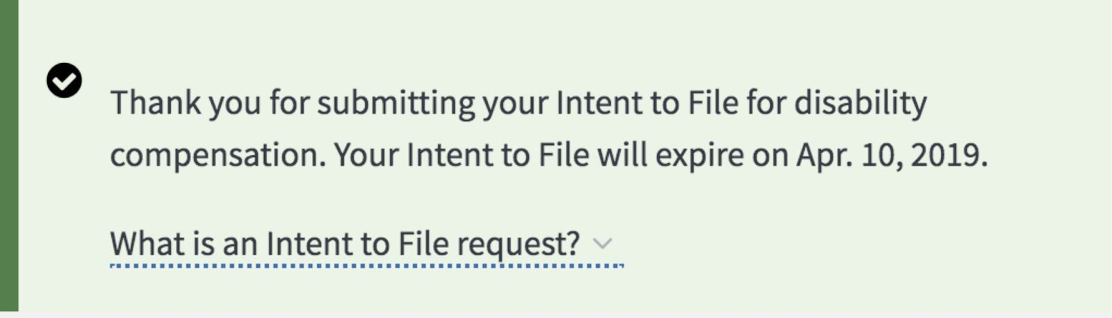

**Veteran already has an ITF submitted**: This message appears if a veteran already as an ITF date on record.

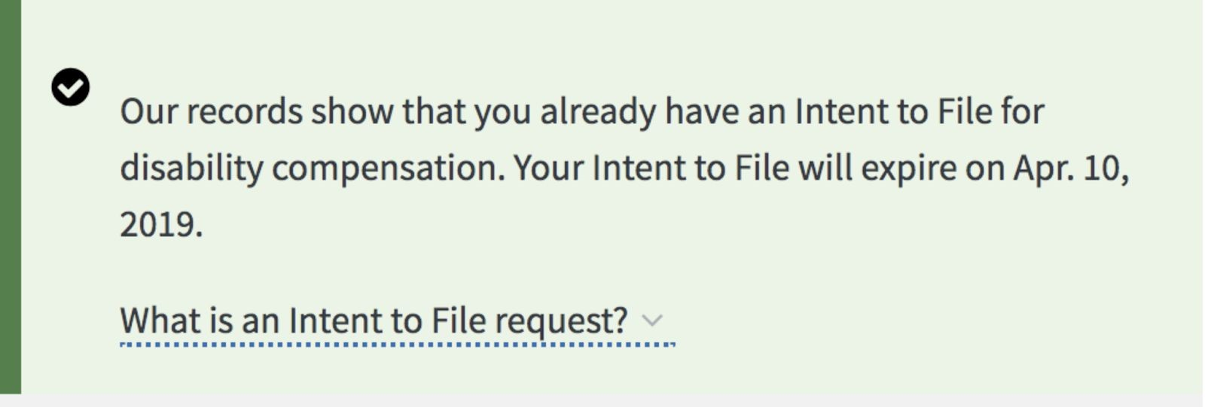

**Veteran has an expired ITF:** If the veteran had an ITF that expired, they will see the below message that a new ITF was created.

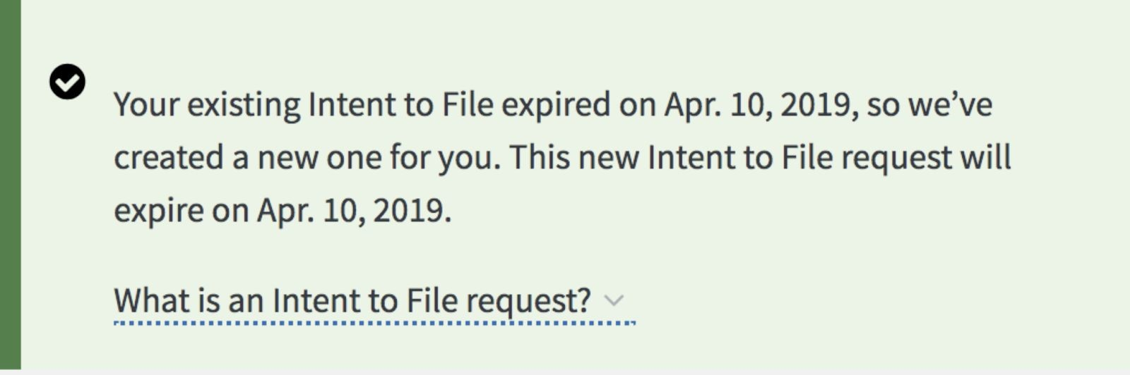

# Application Functionality

## Part 1: Veteran Details:

In this section the Veteran will review their identity and military information to check for accuracy and make corrections as needed.

### Name, Date of birth, Gender

These fields will be pre-populated and can only be viewed in the application. If the user needs them to be changed, they can follow the instructions below the fields.

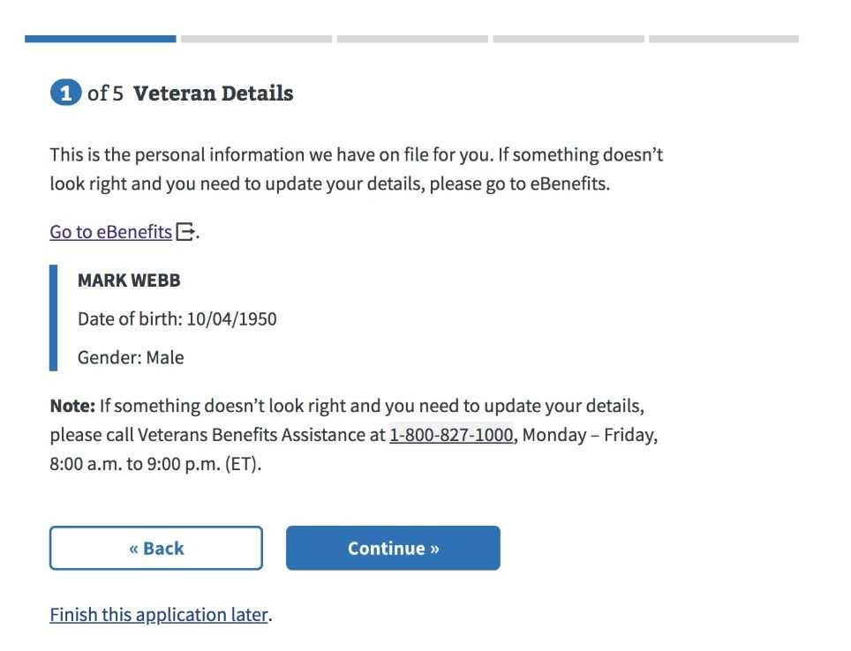

### Contact Information:

Veterans’ contact information is pulled from the Veteran’s profile. Any edits or updates made here will apply only to the 526EZ application.

To update permanent address and email, the Veteran needs to edit this information on their profile page.

### Homelessness

On this screen, Veterans let us know whether or not they are homeless. If they answer “Yes”, we ask the Veteran to provide additional information. If “No”, the Veteran continues to the next screen. .

### High Priority Claims

On this page, we ask the veteran if they are terminally ill to determine whether the claim decision should be expedited.

### Different Name

The application will ask if the user has served under a different name.

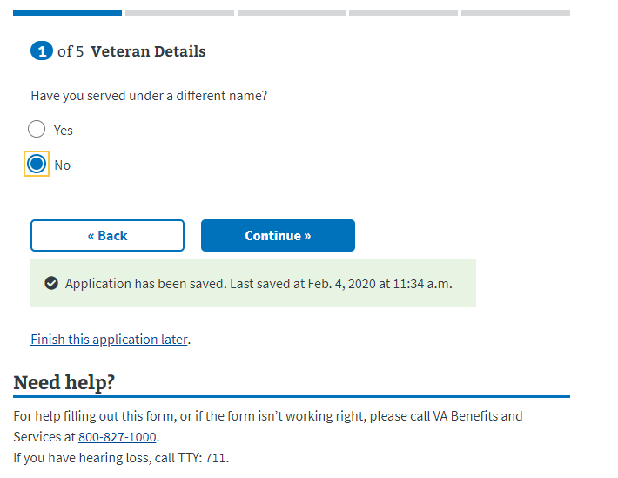

If the user selects “yes”, the page will expand with new fields that must be entered to continue:

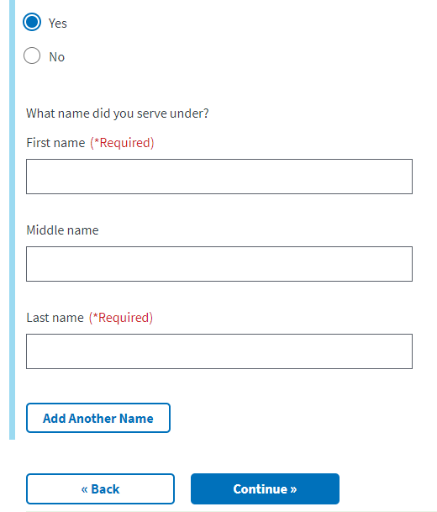

### Military service history

This page will display the military service history the VA has on file for the user. The user can edit this information by clicking the “edit” button and/or add new information by clicking the “Add another service period” button. **Please note, a service end date is required

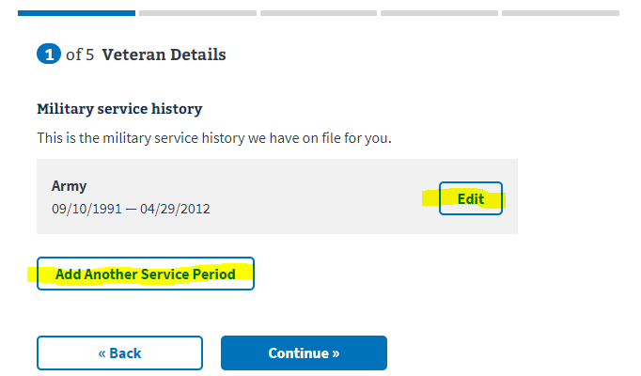

If a user selects to add another service period, the will see the below screen. ­­The user can enter in the new information and then select continue if that is all the changes they need to make to this section. If they want to add another period of service, they should click the “Add another service period.”

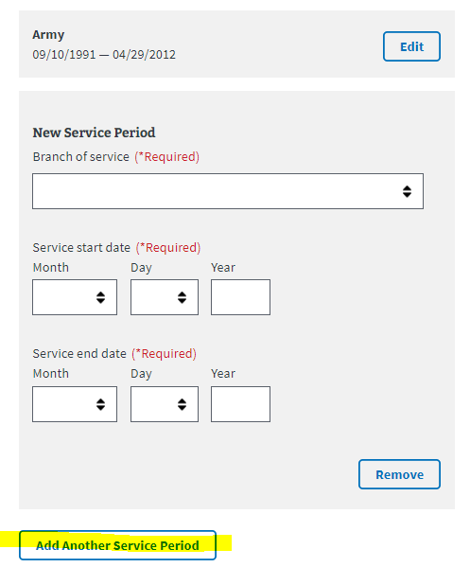

### Separation Pay

Next, the veteran will be asked if they served in a combat zone after September 11, 2001.

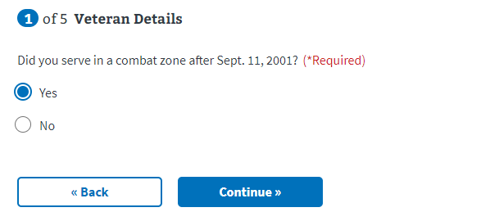

Next, the veteran will be asked if they received separation pay or disability severance pay.

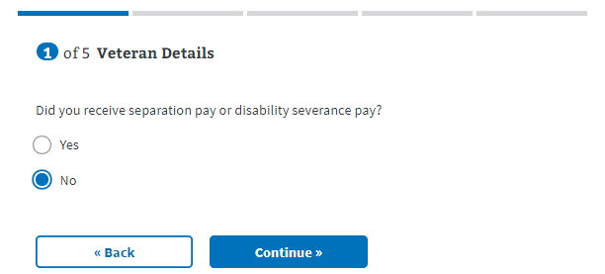

If the user selects no, they will move on to the next page.

If the veteran selects **yes**, they received separation pay or disability severance, the page will expand to show the following:

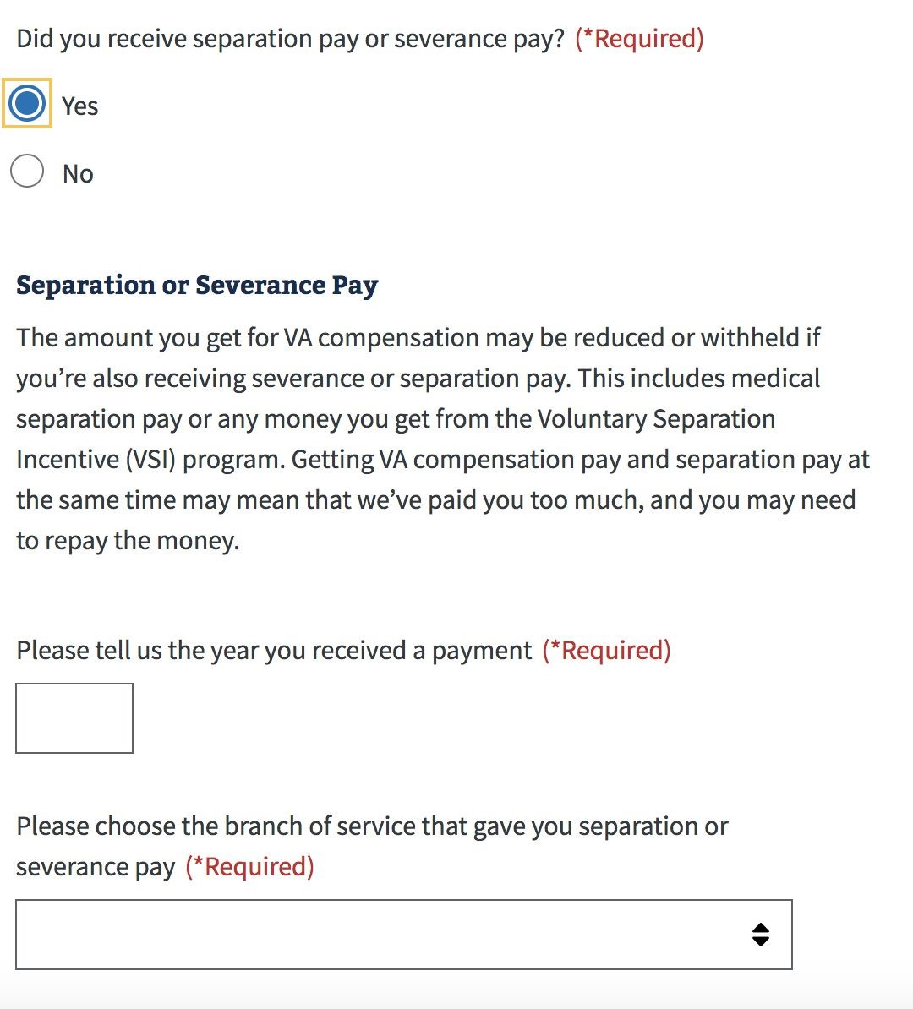

### Retirement Pay and Training Pay

If a user has received retirement pay, they will be required to choose the branch of service that gave them the retire pay. If not, they will be taken to the next page.

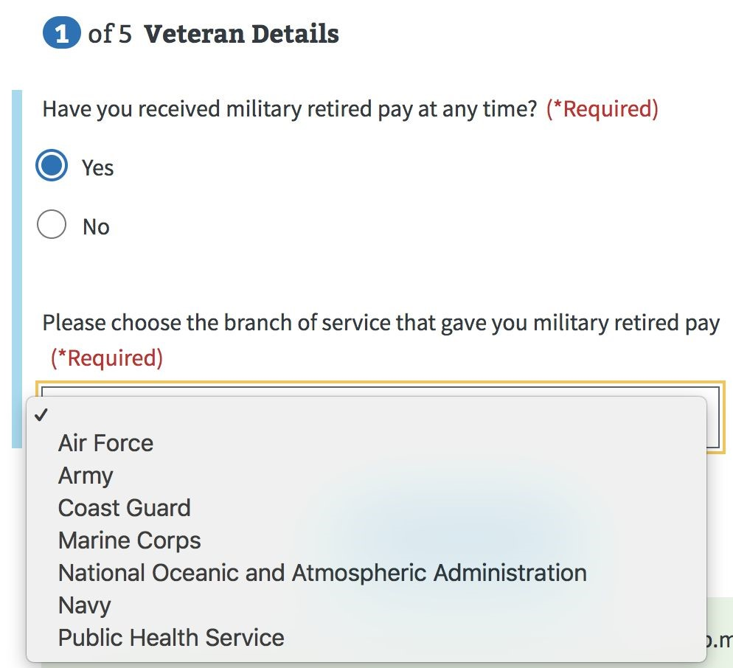

### Training Pay

Next, the veteran will be asked if they expect to receive active or inactive duty training pay.

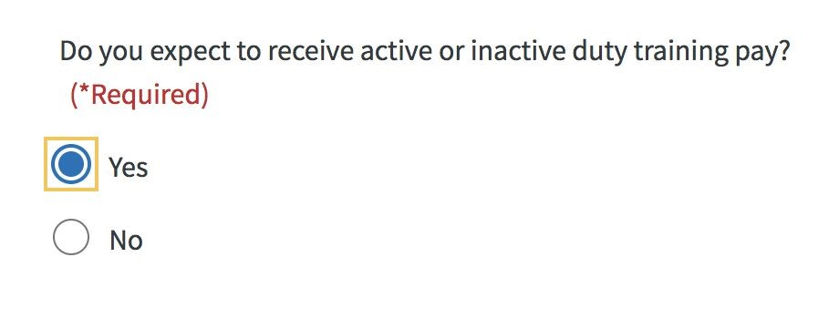

## Part 2: Disabilities

### Rated Disabilities

The Rated Disabilities screen displays a Veteran’s rated service-connected disabilities. They can choose the condition that they’re filing for an increase because the condition has gotten worse.

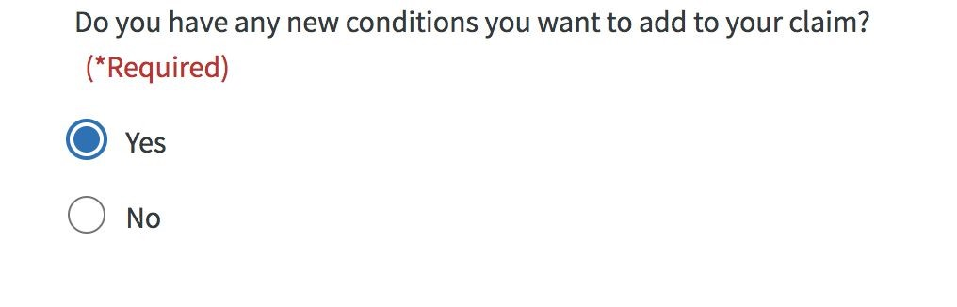

### New Disabilities

The New Disabilities screen asks a Veteran to describe or provide information about their new disabilities. (Short answers are better here. A Veteran will have an opportunity to provide more details on the following screen.) As the veteran types in the text box, a drop down will appear with possible terms. The veteran can select from these or continue typing what they would like to enter. They can also add multiple disabilities to the claim by selecting the “Add another disability” button.

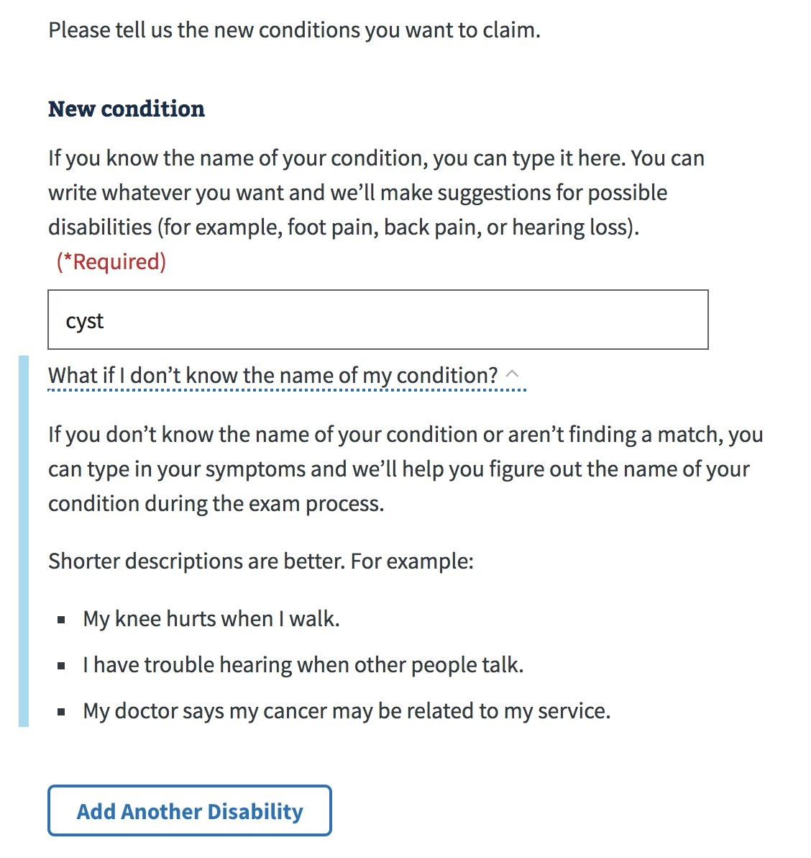

Veterans will be asked how their disability is related to their service. There is a dropdown for each of the options listed and the user must answer.

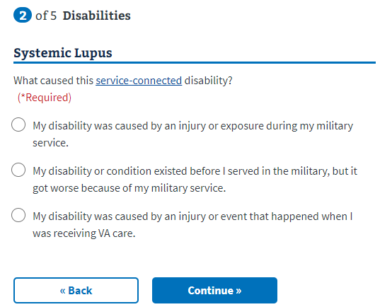

A Summary of Disabilities screen will show new and rated conditions the Veterans is claiming.

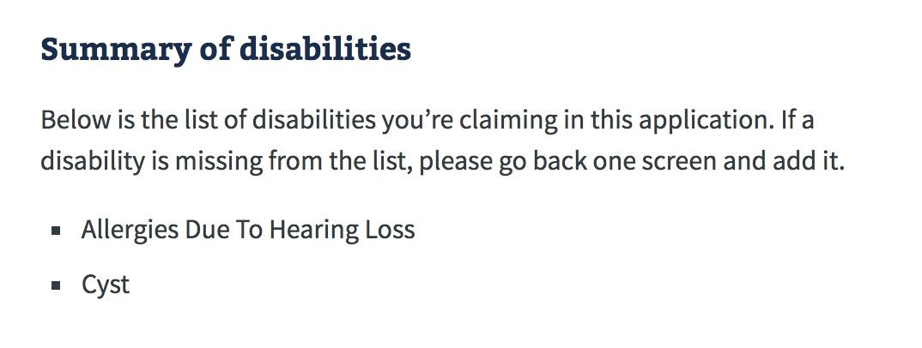

If the Veteran is a Prisoner of War, they’ll be asked if any of their new conditions is related to their POW experience.

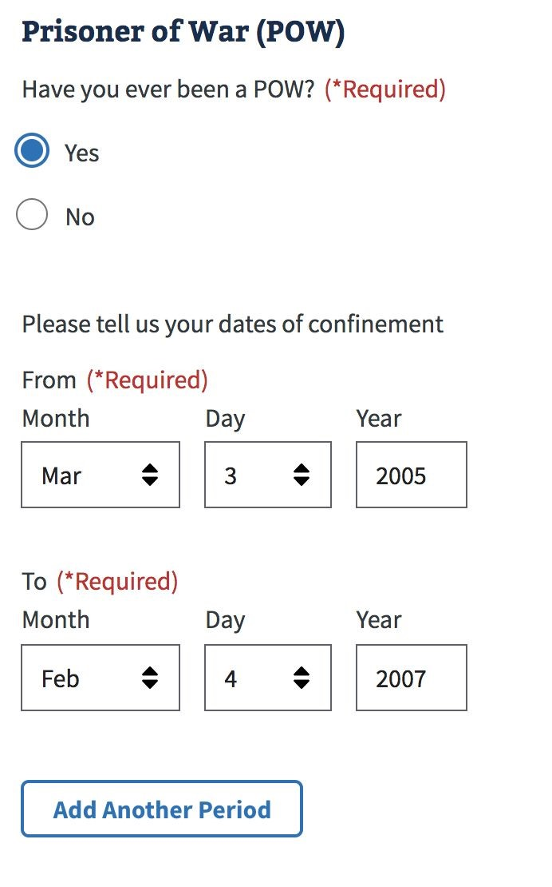

### Ancillary Wizard

The Ancillary Forms Wizard asks the Veteran questions about their situation to determine if they’re eligible for additional disability benefits. Based on the Veteran’s answers, the wizard will suggest supplemental forms a Veteran can file with their disability claim. (For example, Aid and Attendance benefits, Adaptive Housing benefits, Automobile Allowance, Individual Unemployability.)

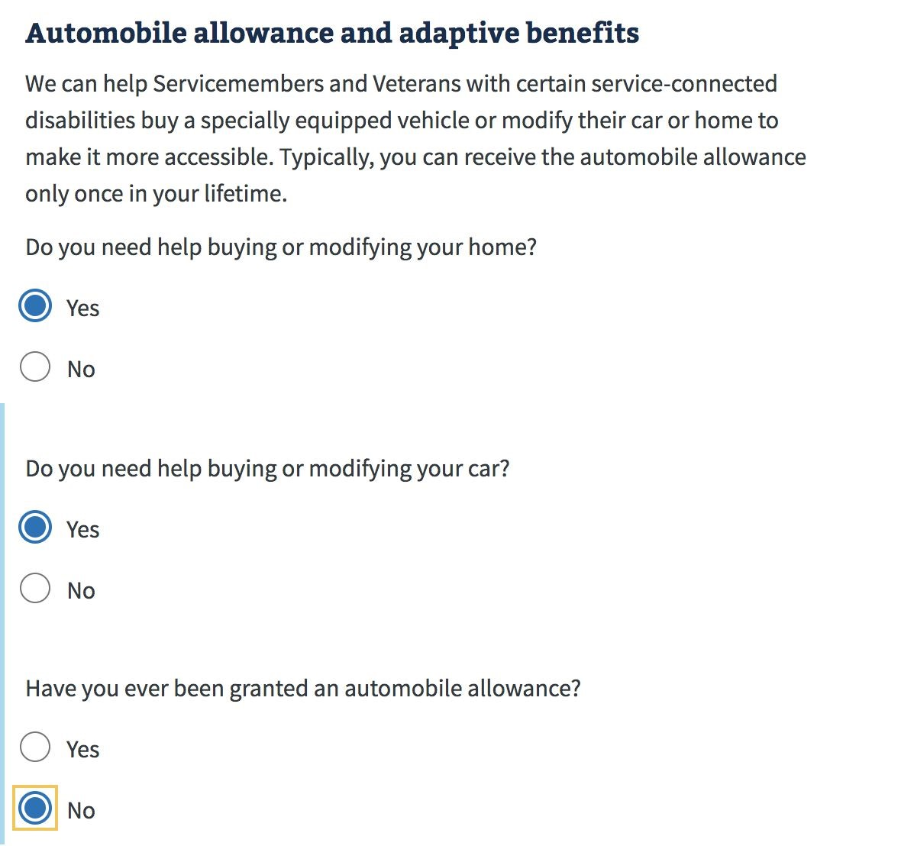

The suggested forms are summarized in a screen for download.

## Part 3: Supporting Evidence

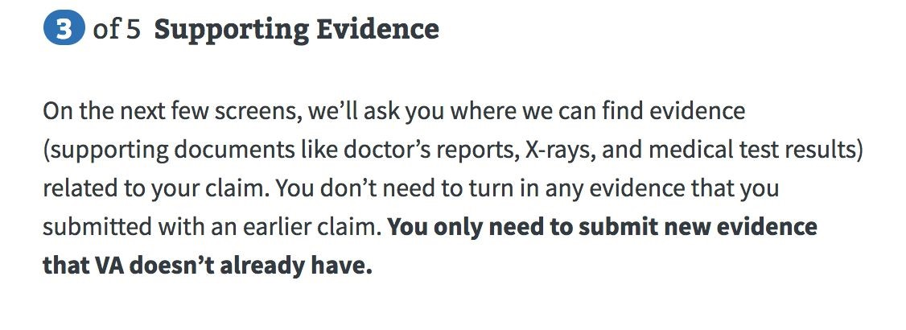

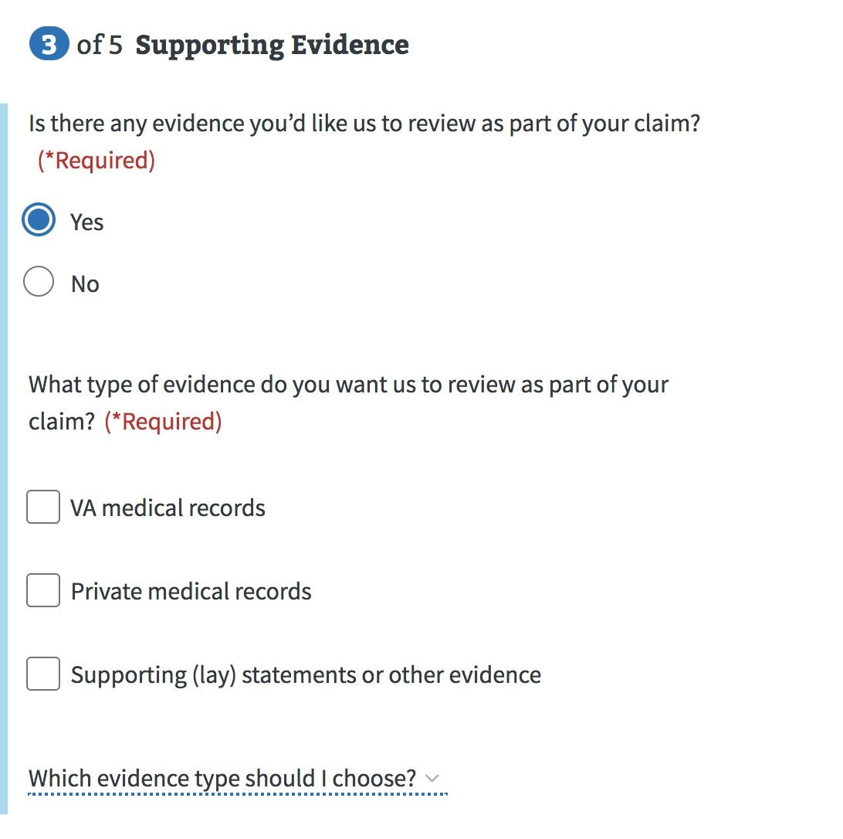

### VA Medical Records

### Private Medical Records

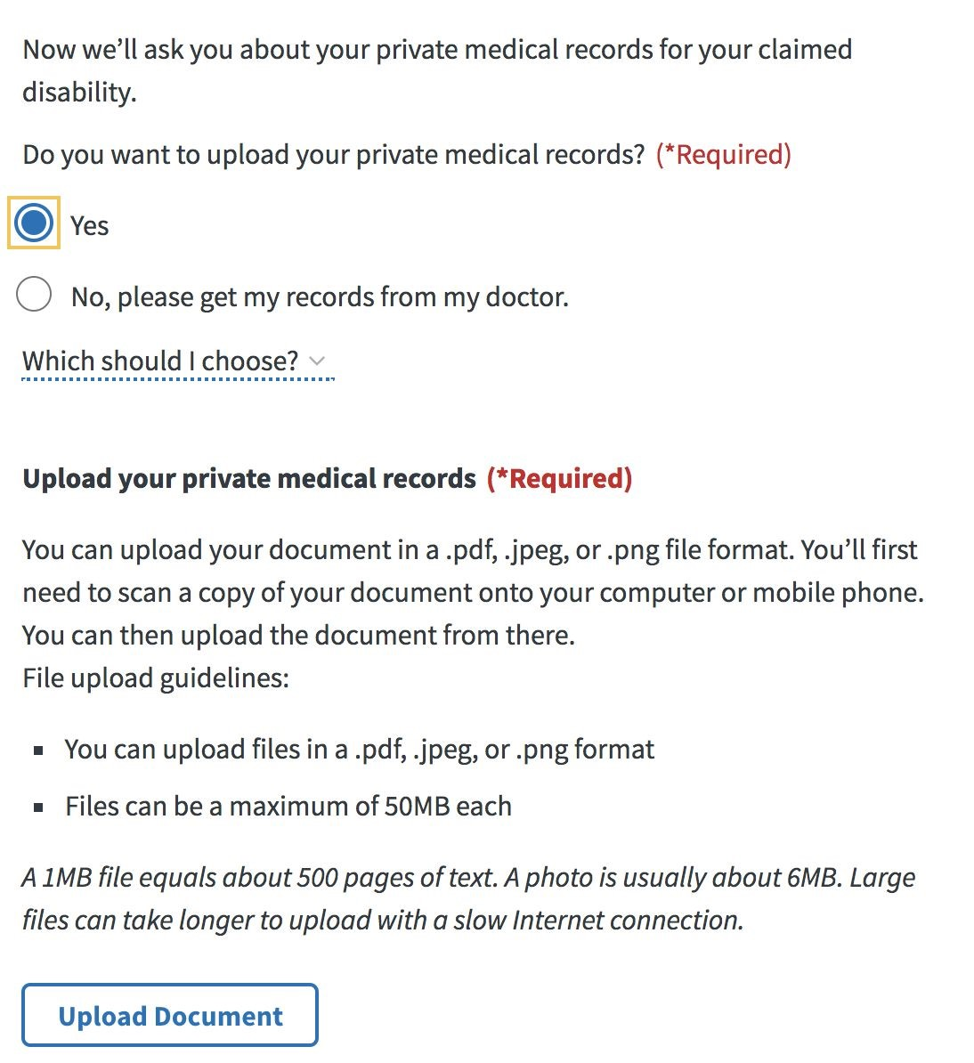

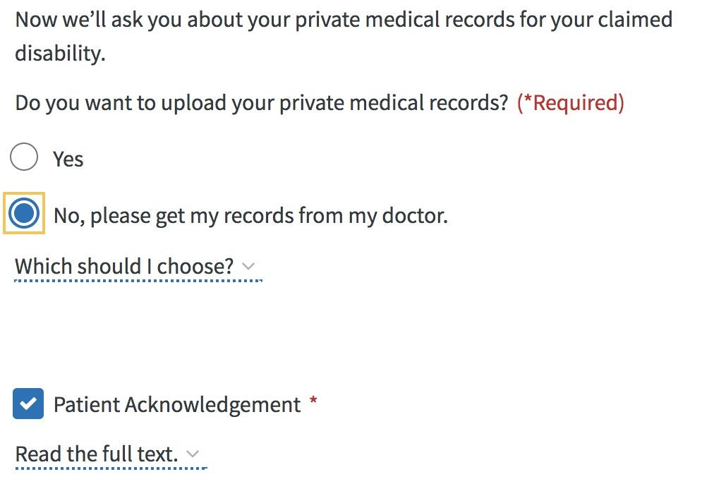

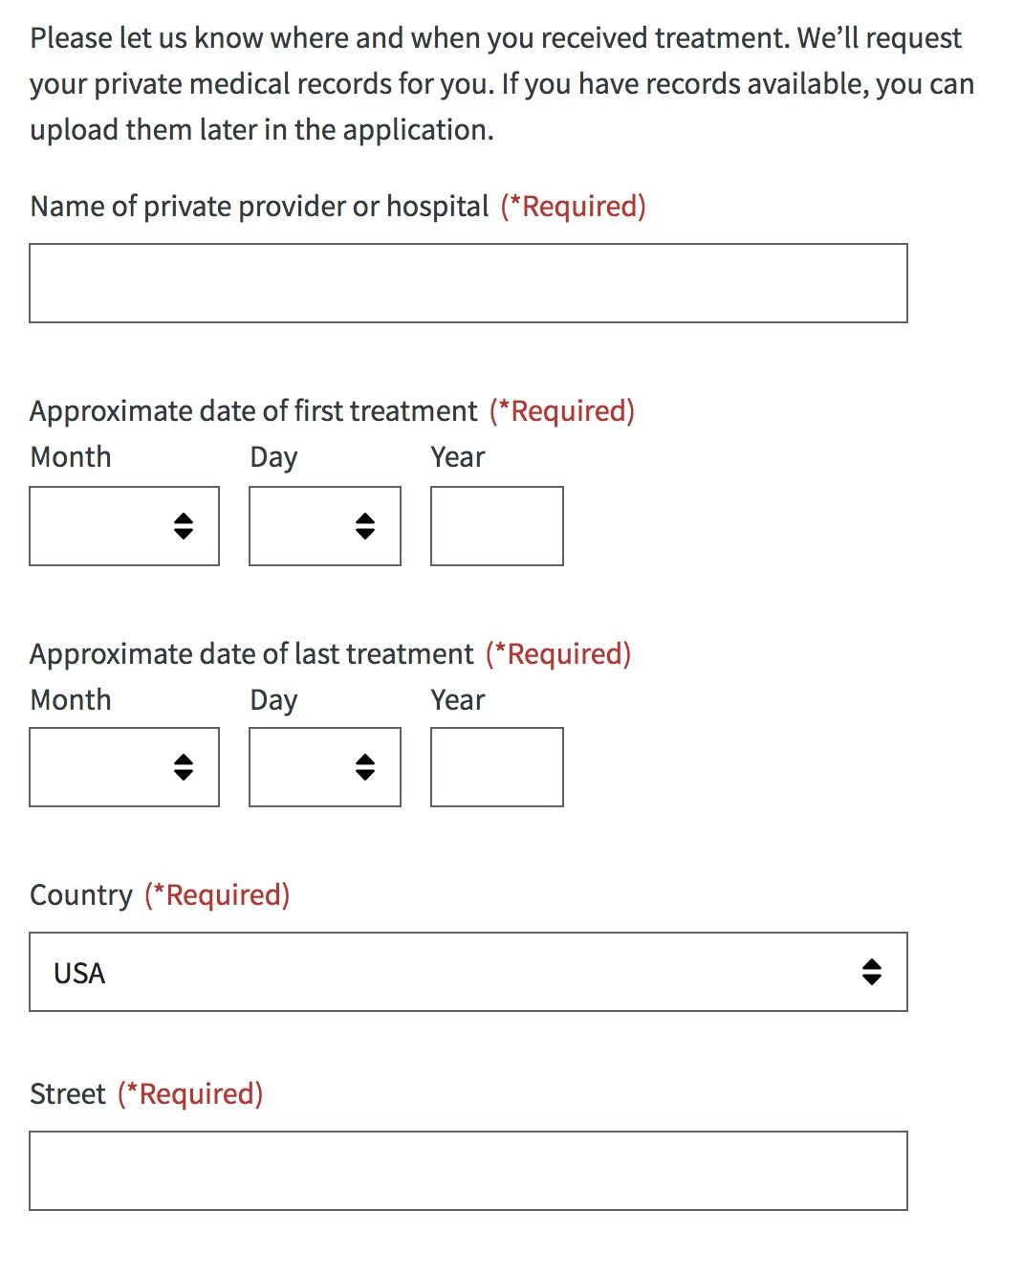

### Exam Info

On the Exam screen, Veterans can find answers to common questions about a claim exam in the dropdown by selecting the ‘+’ icon.

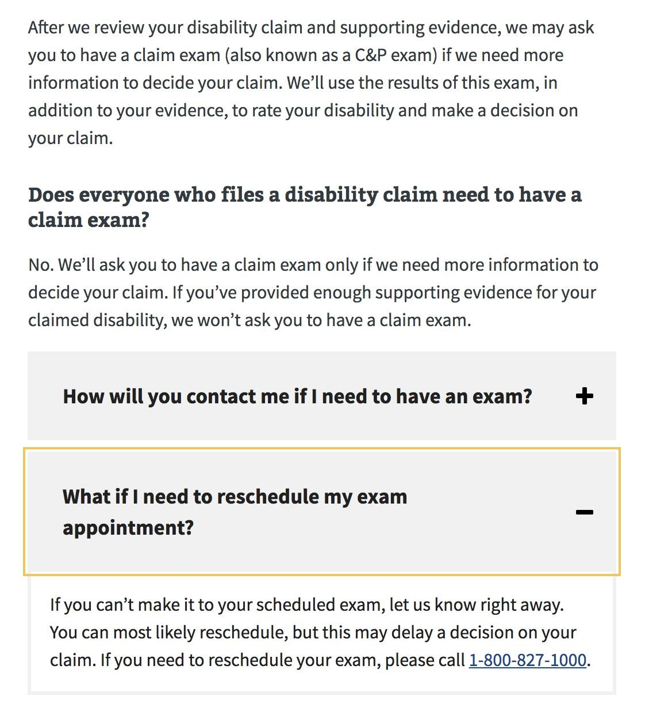

## Part 4: Additional Information

### Payment Info

Veteran payment information is pre-populated if it exists in the Veteran’s record.

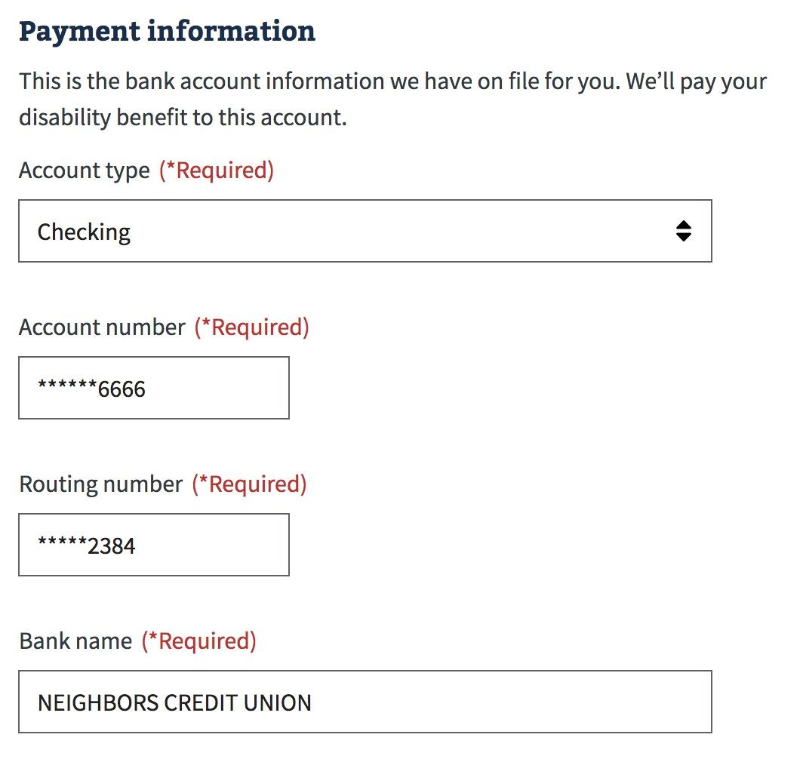

This information can be edited for the 526 application by adding a new account. But the user will receive the below message that the update won’t automatically occur across systems. If the user wants their direct deposit information to be changed now, they should complete that in their profile:

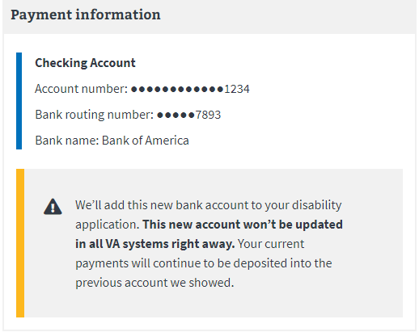

### VA Employee

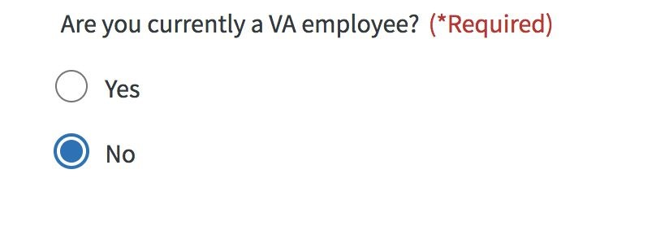

### Retirement Pay Waiver

If a Veteran indicates earlier in the application that they receive retirement pay, we show the following waiver screen.

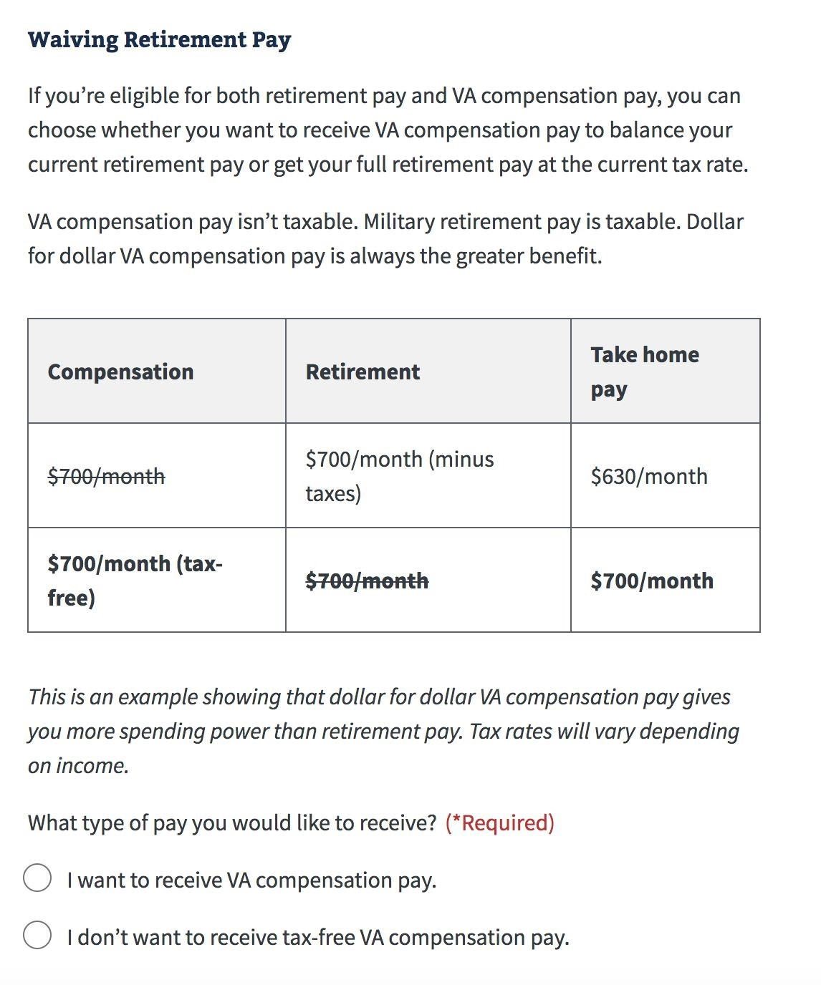

### Training Pay Waiver

If a Veteran indicates earlier in the application that they expect to receive training pay, this page explains to the veteran they can NOT receive VA compensation for the same days they receive training pay. This form requires the veteran select whether they want to waive their training pay and instead receive VA compensation or waive VA compensation for the days they receive training pay. This page indicates training pay is typically more than compensation pay.

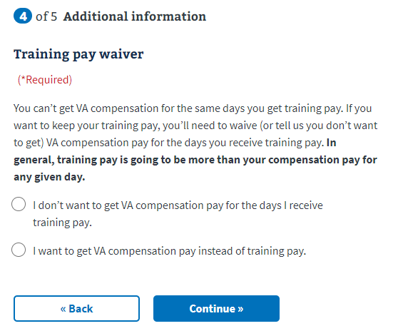

## Part 5: Review Application

Before submitting their application, Veterans can review each section of the form for accuracy, using the ‘+’ toggle buttons to reveal detailed information. In order to submit the application, acceptance of the privacy is required by clicking the provided checkbox.

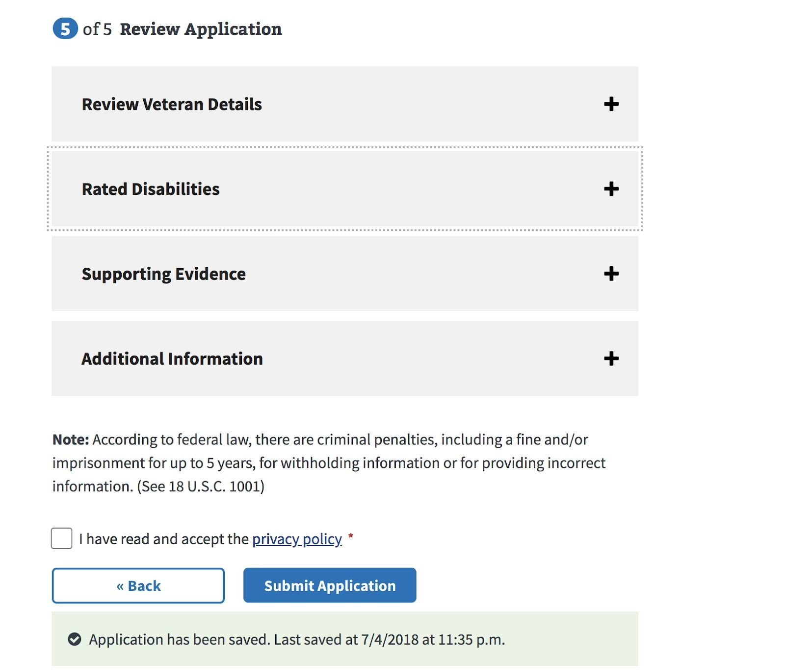

Successful Submission: Submitted applications will receive a confirmation message that contains a ​**‘Claim ID’**​ number that Veterans can use to track their application. A Veteran should be able to review the status of their claim using the Claim Status tool within 24 hours of submitting.

After Submit: A claim is electronically created for the Veteran in the VBMS database for VBA. In addition, a pdf version of the 21-526-EZ form is created and sent to the National Work Queue to be reviewed. .

### Success Confirmation

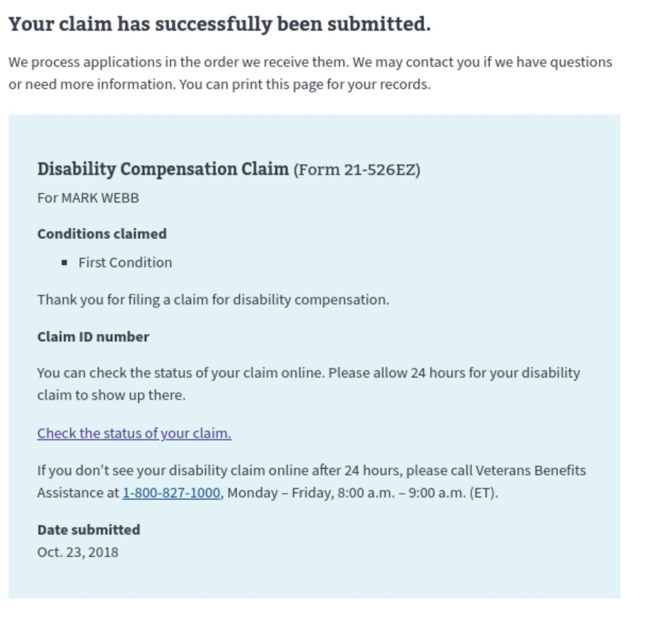

### Check back later Confirmation message

Veterans will see this message when there is a backup of submissions in the queue. The system will retry submitting the application until successful within a 24-hour period.

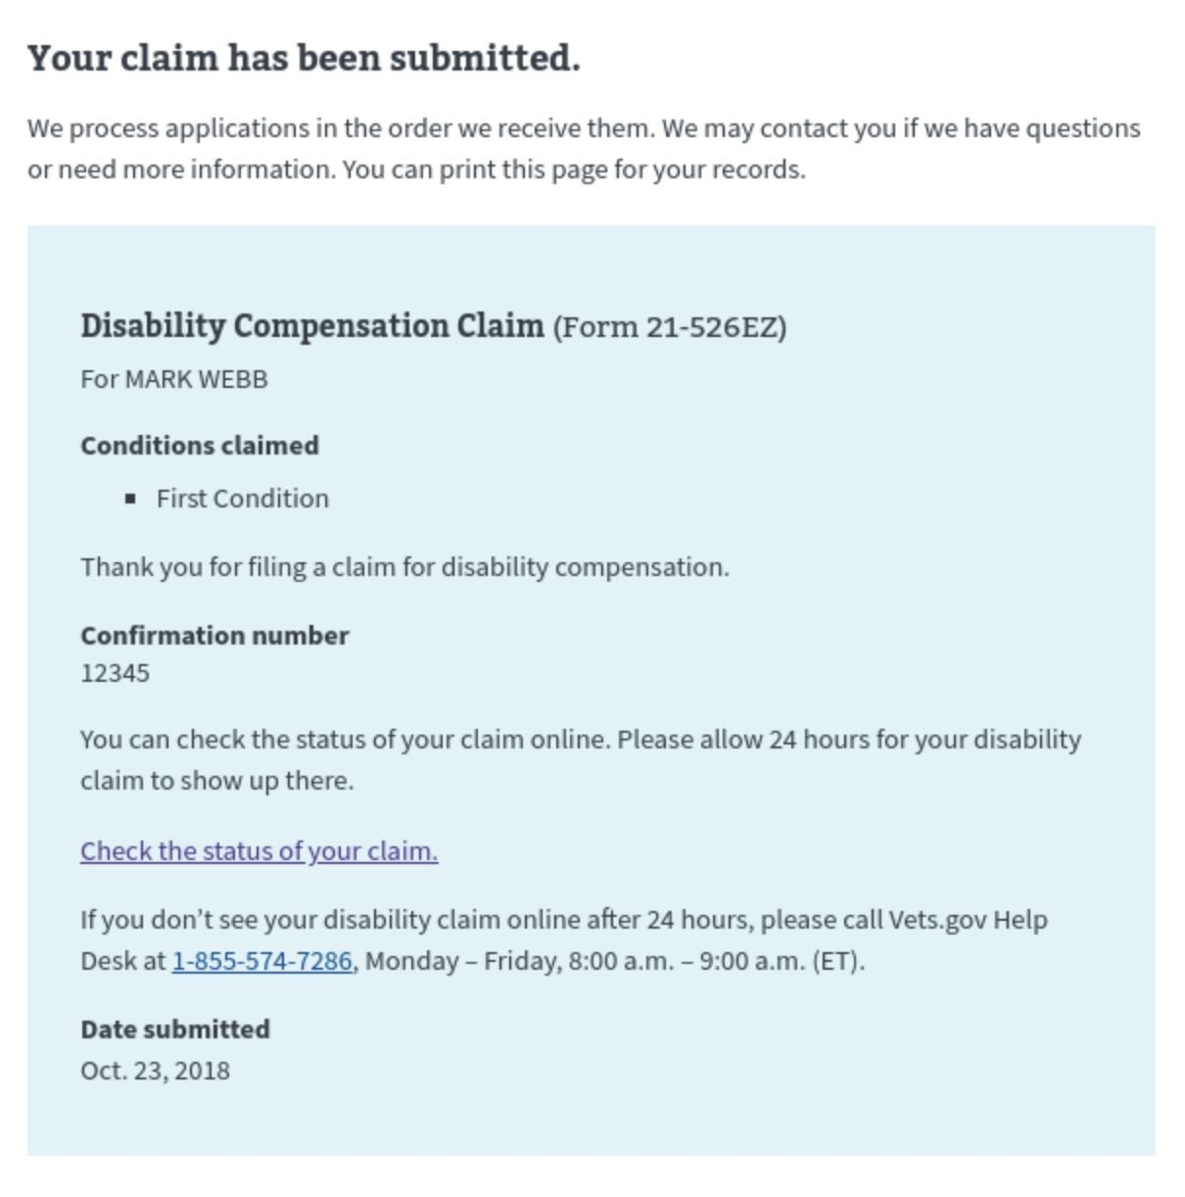

### Error confirmation

A Veteran might see this error submission message when there is a partner service outage, site maintenance or downtime, or problem with the data quality.

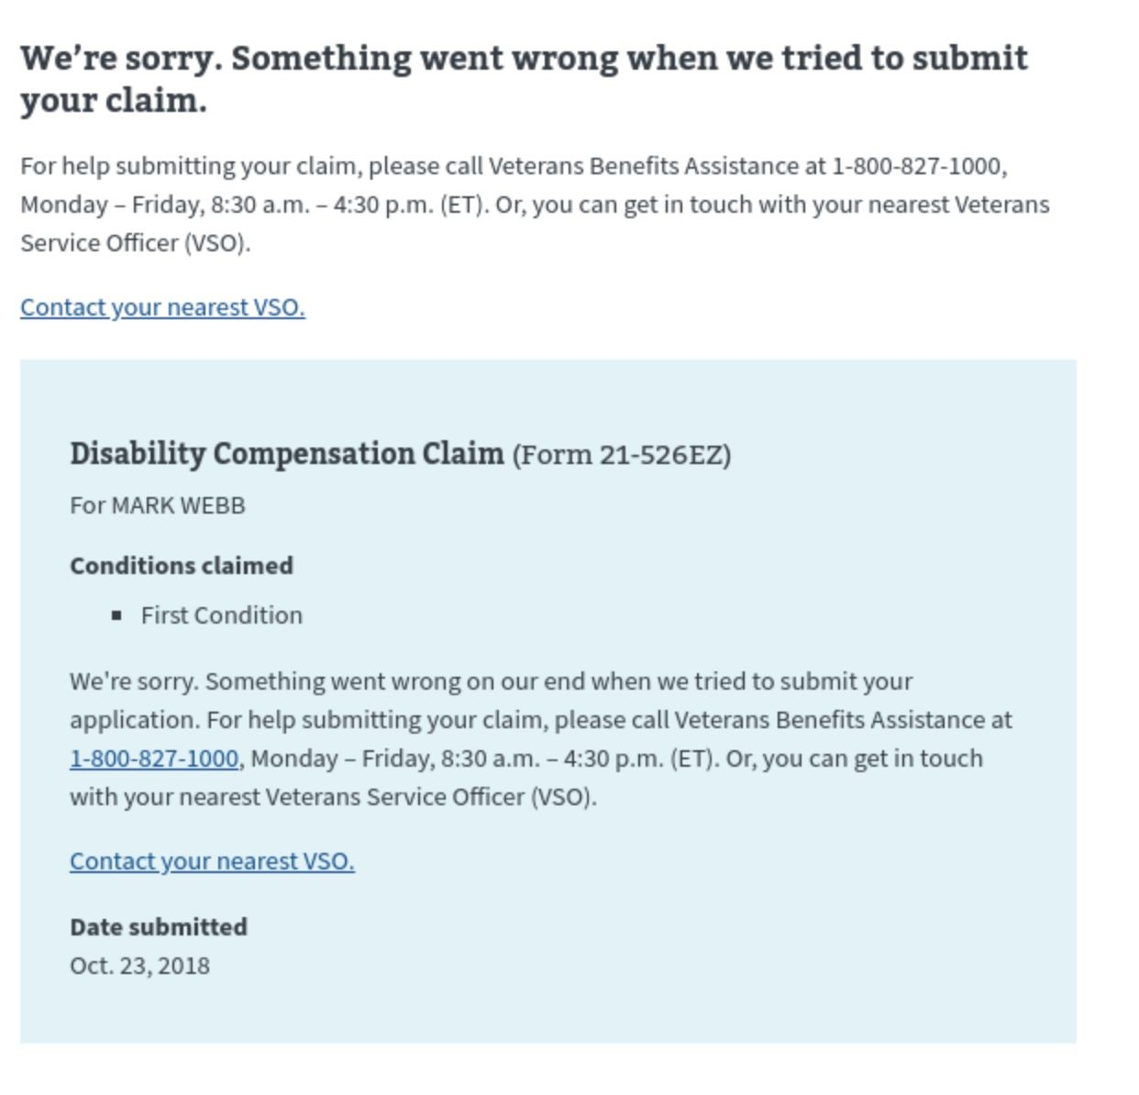

# Major Issues and Error Messages

## Can’t access application because of account

If a user is signed into an LOA1 (not identity verified) account or are signed into an LOA3 (identity verified) account that does not have matching records in MVI, they will see the below error message when trying to access the 526-EZ application:

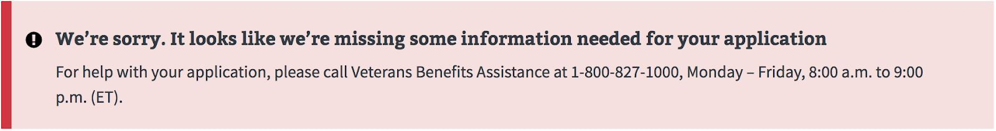

To troubleshoot this issue, the agent should ask the user to go to their account page by selecting the dropdown arrow next to the name or email address in the upper right hand corner and then selecting “Account”

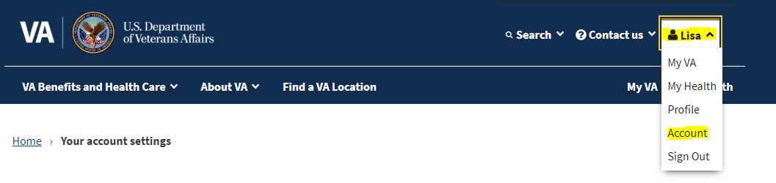

If the veteran only has an LOA1 account (not identity verified) they will see the below message and will have to verify their identity to complete the application:

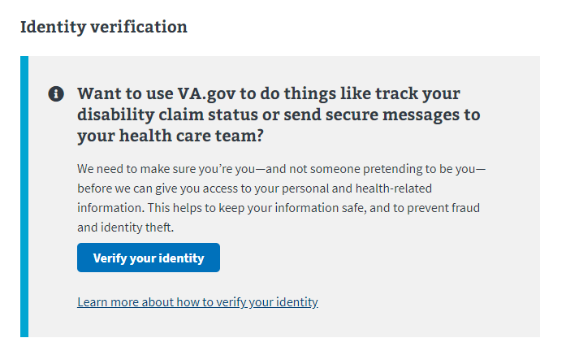

If the veteran has an LOA3 account (identity verified) but the information does not match the records found in MVI, they will see the below message and will have to follow the instructions to update their records:

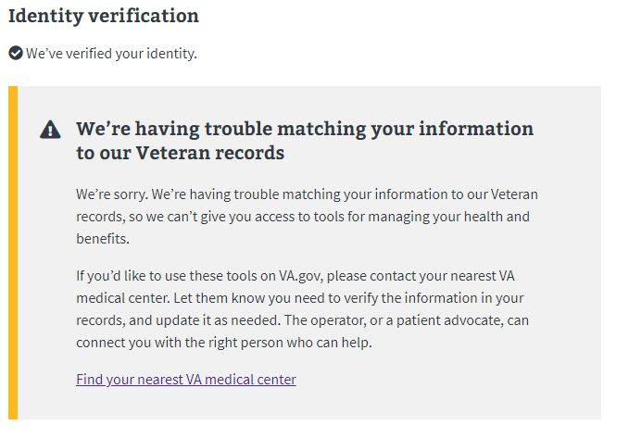

## Intent to File (ITF) Error Messages

Sometimes the system will have trouble **creating the ITF**. If this happens, explain to the user that there is likely an issue happening with the system and suggest that the user try again at a different time. If the user calls back and says the problem has persisted for several hours/days, this should be escalated to the VA.gov technical support team.

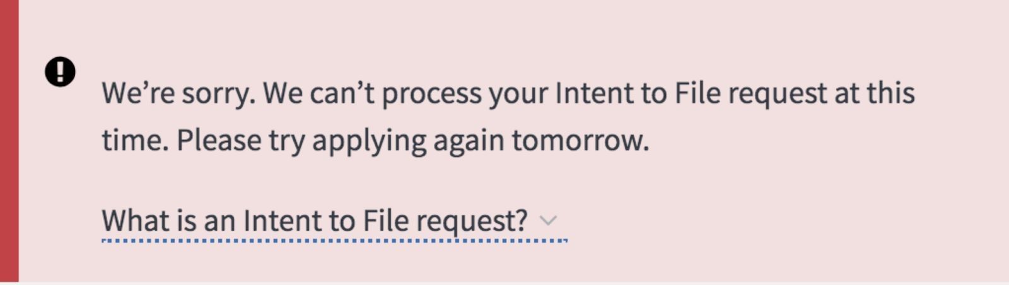

Sometimes the system will have trouble **accessing an ITF that already exists**. If this happens, explain to the user that there is likely an issue happening with the system and suggest that the user try again at a different time. If the user calls back and says the problem has persisted for several hours/days, this should be escalated to the VA.gov technical support team.

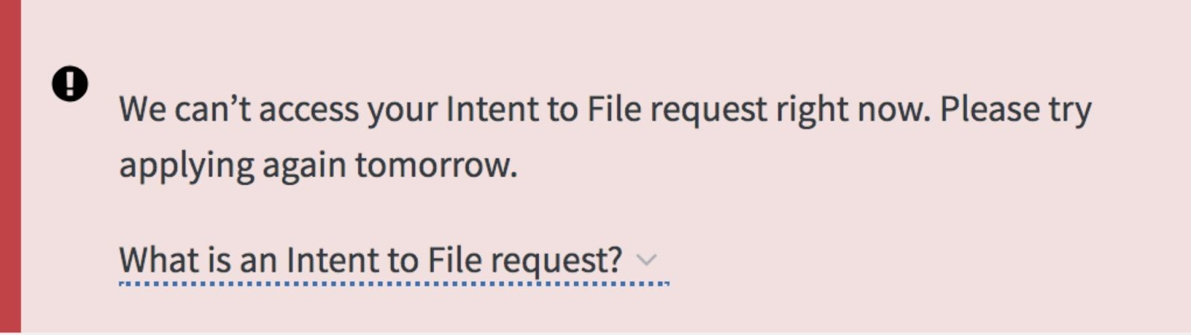

Sometimes the system will have trouble **renewing** an ITF that already exists. If this happens, explain to the user that there is likely an issue happening with the system and suggest that the user try again at a different time. If the user calls back and says the problem has persisted for several hours/days, this should be escalated to the VA.gov technical support team.

|  |
| --- |
|  |

## Save in Progress Messages

The following table contains the message types and notifications that would appear for standard errors and failures. Some messages may vary slightly as we develop updates versions of the tool.

|  |  |  |  |
| --- | --- | --- | --- |
| Scenario | Title | Description | Location |
| Save in progress data |  | Application has been saved. Last saved on m/dd/yyy at HH:MMam/pm | Below affected component |
| Unable to complete an automated task (e.g. save application in  progress) | We couldn't save your form | We're sorry. Something went wrong when we tried to save your form. If you're on a secure and private computer, you can leave this page open and try saving your form again in a few minutes. If you're on a public computer, you can continue to fill out your form, but it won't automatically save as you fill it out. | Below affected component |